Anatomy of Backbends
- As you practice Dhanurasana v. Ustrasana note the intensity of where muscle contraction takes place. Please describe the difference in how the muscles are working in these pose examples. Can you think of other poses similar in nature to either dhanurasana and ustrasana?

- Discuss why engaging the abdominal wall, especially transversus abdominus, is important during backbends (KM pg. 125).

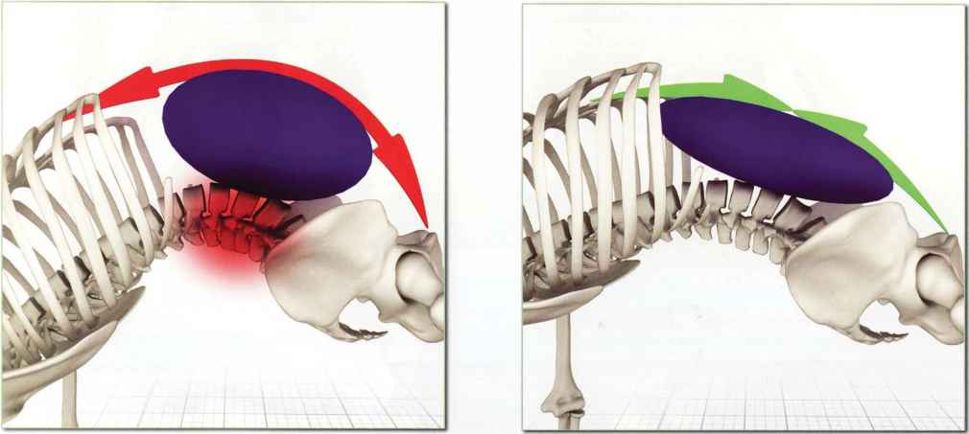

3. Label the abdominal muscles.
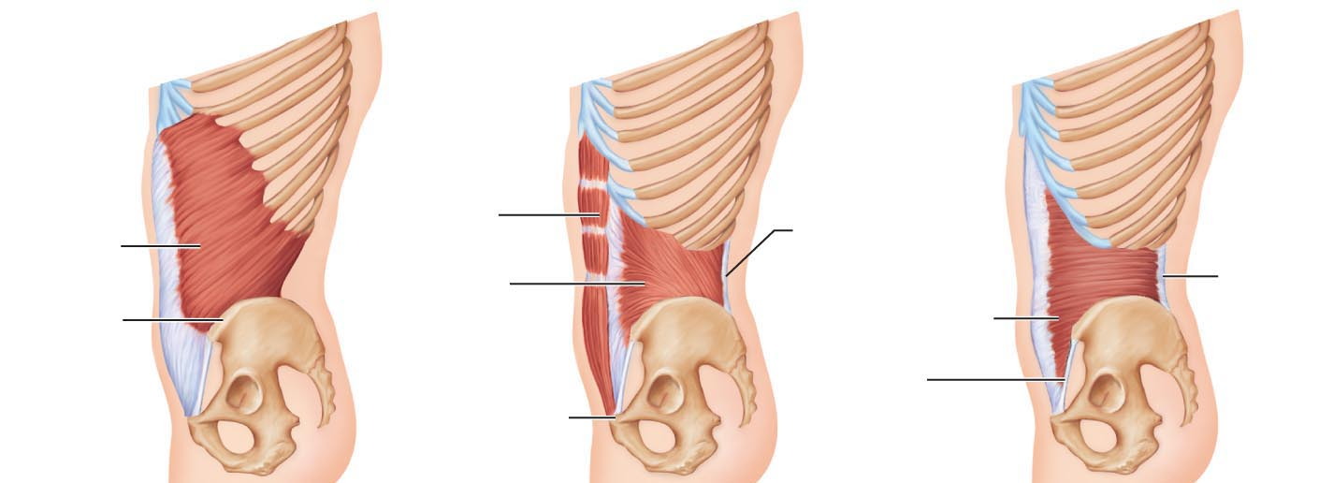

Need to knows:
- The main muscles of backbending.
- The importance of core-engagement, abdominal muscle contraction, during back bending. The air bag effect.
- Abdominal muscles

Associated Reading:

            - Manual: pgs. 82-88, 138-141
            - Key Muscles: 118-125, 128-133

Bonus: List and identify, using Key Muscles, the muscles of the Posterior Chain! From the manual on pg. 83, describe the general position of core muscles in relation to muscles that generate large, powerful movements.

