Anatomy of Balance Poses
1. In balance poses, practice, observe, and discuss how core activation promotes proper hip alignment.
_________________________________________________________________________________________________________________________________________________________________________________________________________________________________________________________________________________________________________________________________________________________________________________________________________________________________________
2. What is joint reaction force? Using KM, discuss how joint reaction forces are in play between the hip and knee joint.
______________________________________________________________________________________________________________________________________________________________________________________________________________________________________________________________________________________________________________________________________________________________________________________________________________________________________________________________________________________________________________________________
3. What is muscular co-activation? Discuss how muscular co-activation aligns the hip and protects the knee joint in balance poses.
___________________________________________________________________________________________________________________________________________________________________________________________________________________________________________________________________________________________________________________________________________________________________________________________________________________________________________________________________________________________________________________________________________________________________________________________________________________
4. For synovial joints in general, list from most stabilizing to least the following features: shape of the articulating surfaces, muscle tone and tendon attachments across the joint, and the joint capsule and ligaments.
_________________________________________________________________________________________________________________________________________________________________________________________________________________________________________________________________________________________________________________________________________________________________________________________________________________________________________

5. Label the following knee structures: tendon of quadriceps femoris, patellar ligament, medial and lateral retinaculum, patella, medial (tibial) collateral ligament, lateral (fibular) collateral ligament, anterior and posterior cruciate ligaments.

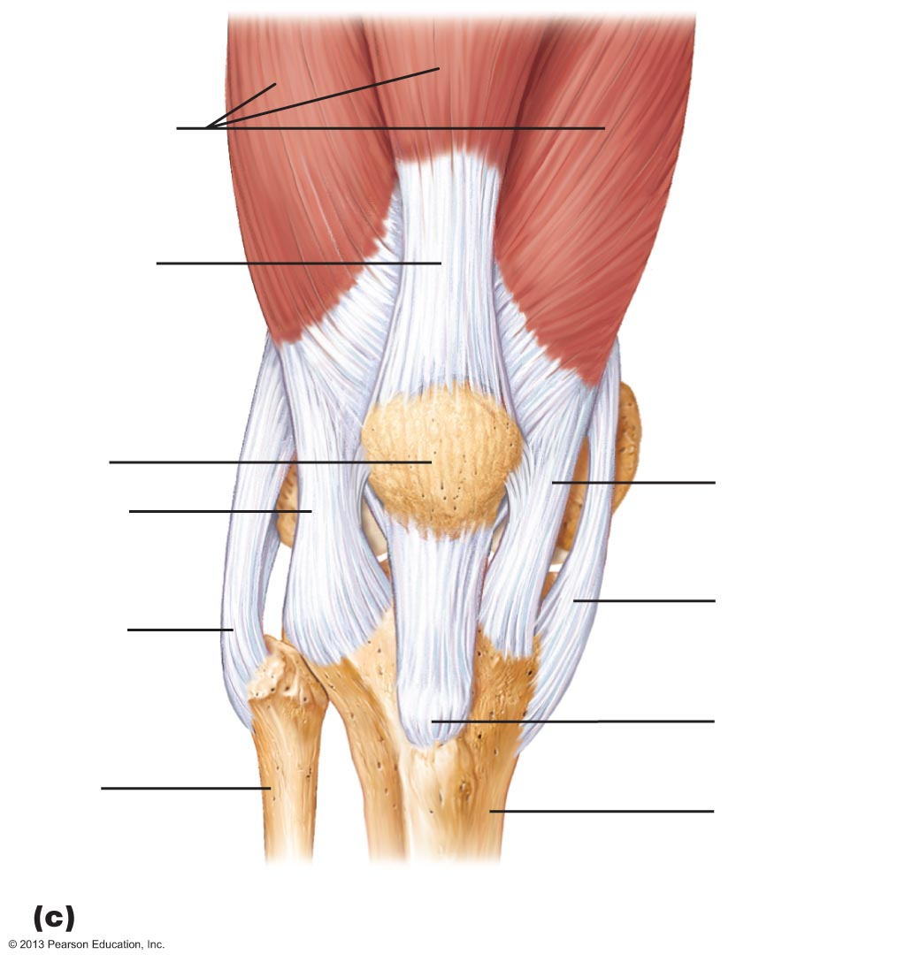 | 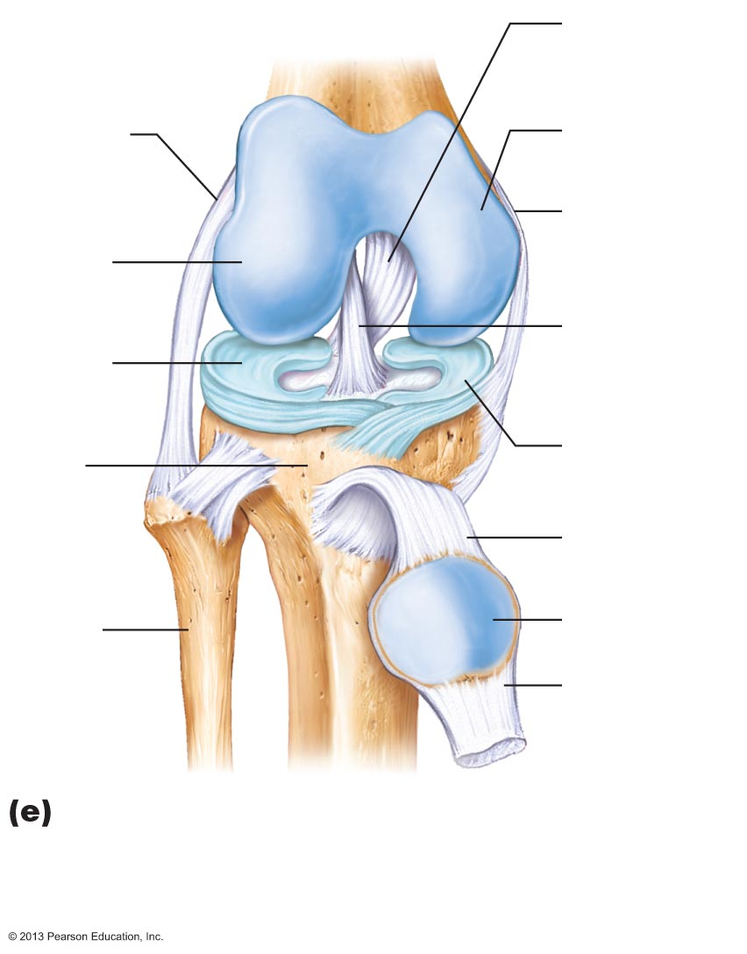

6. BONUS—What are the basic characteristics of all synovial joints? See additional handout
________________________________________________________________________________________________________________________________________________________________________________________________________________________________________________________________________________________________________________________________________________________________________________________________________________________________________________________________________________________________________________________________________________________________________________________________________________________________________________________________________________________________________

Need to knows:
- Joint reaction forces—how/why does this happen
- Muscular co-activation—how/why is this beneficial
- Basic knee anatomy (#5)
Recommended reading:
- Manual pgs. 174-175, 76-77
- KM pgs. 24-25
Synovial Joints: Six Distinguishing Features

1. Articular cartilage: hyaline cartilage

Prevents crushing of bone ends

2. Joint (synovial) cavity

Small, fluid-filled potential space

3. Articular (joint) capsule

Two layers

External Fibrous layer

Dense irregular connective tissue

Inner Synovial membrane

Loose connective tissue

Makes synovial fluid

4. Synovial fluid

Viscous, slippery filtrate of plasma and hyaluronic acid

Lubricates and nourishes articular cartilage

Contains phagocytic cells to remove microbes and debris

5. Different types of reinforcing ligaments

Capsular

Thickened part of fibrous layer

Extracapsular

Outside the capsule

Intracapsular

Deep to capsule; covered by synovial membrane

6. Nerves and blood vessels

Nerve fibers detect pain, monitor joint position and stretch

Capillary beds supply filtrate for synovial fluid

Three Stabilizing Factors at Synovial Joints

Shapes of articular surfaces (minor role)

Ligament number and location (limited role)

Muscle tendons that cross joint (most important)

Muscle tone keeps tendons taut

Extremely important in reinforcing shoulder and knee joints and arches of the foot

