Anatomy of Twists
1. When taking turns practicing either seated twists, Ardha Matsyendrasana or Bharadvajasana, observe/sketch degree of health rotation in each spinal region. What do you notice about the position of the pelvis during these twists, is it rigidly static, or is there a small amount of movement?
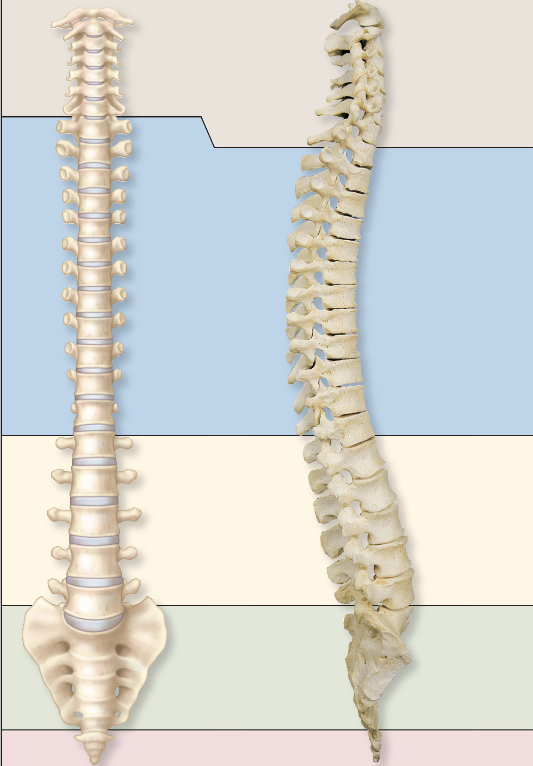
2. Intercostal muscles engage more fully as we deepen our twists. Practicing a twist yourself, describe what is occurring with the abdominal cavity and the diaphragm that results in using more intercostals.
________________________________________________________________________________________________________________________________________________________________________________________________________________________________________________________________________________________________________________________________________________________________________________________________________________________________________________________________________________________________________________________________________________________________________________________________________________________________________________________________________________________________________

3. Label the following muscles: Serratus Anterior, rhomboids, levator scapulae, pectoralis minor, and trapezius. and match them to the following actions of the scapula—protraction, retraction, elevation, depression. More than one movement may apply. How are these muscles activated in twists? Would these muscles be activated first or later in the twist?
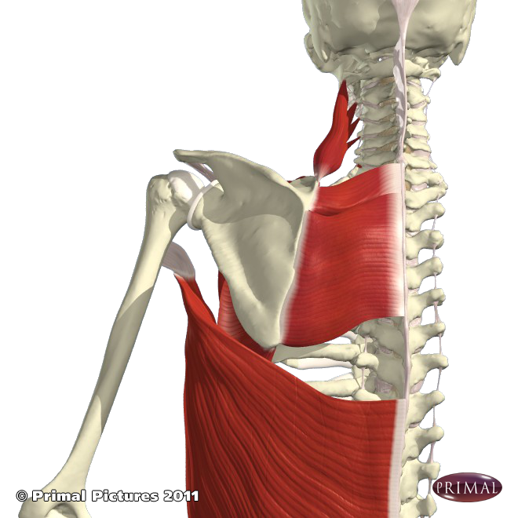 | 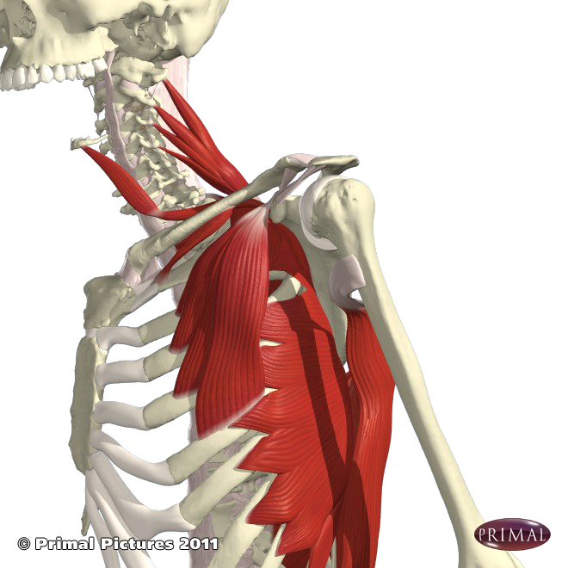
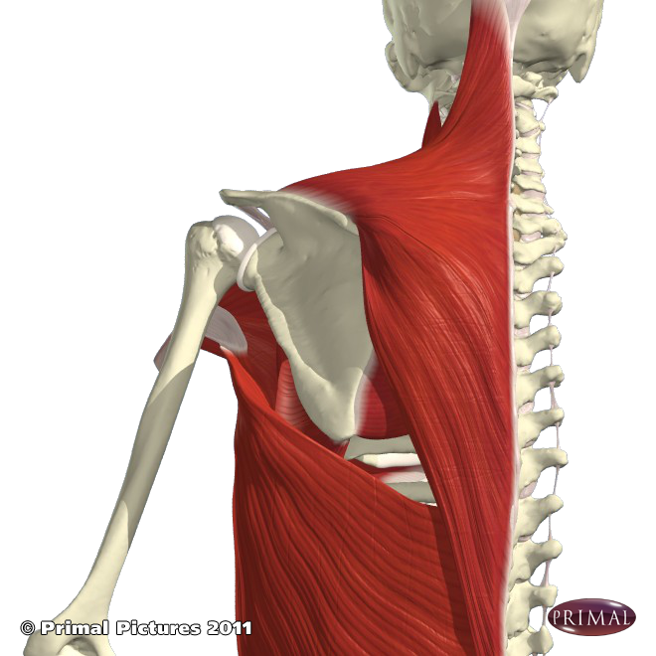 | 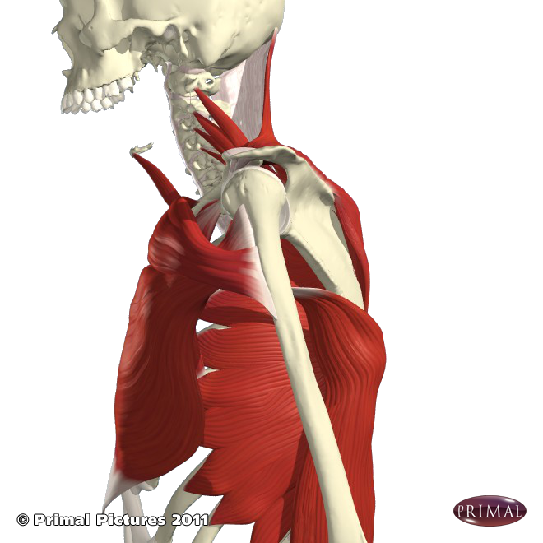

Need to Knows:
- Most mobile to least mobile spinal regions for rotation (twisting) and why is that?
- Muscles that twist: external and internal obliques and erector spinae
- Scapular muscles: serratus anterior, trapezius, and rhomboids
- Pectoralis Major and Latissimus Dorsi

Suggested Reading:
- Manual pgs. 82-84, 160-163
- Key Muscles pgs. 113-133 (review), 135-166

