Anatomy of Standing Poses Revisited: Adductors and External Rotators of the Hip

1. As you physically transition between parsvottanasana to trikonasana, describe how you notice the stretching of the thigh muscles change in the forward leg.
______________________________________________________________________________________________________________________________________________________________________________________________________________________________________________________________________________________________________________________________________________________________________________________________________________________________________________________________________________________________________________________________________________________________________________________________________________________________________________________________________________________________________________________________________________________________________________________________________________________________________________________________________________________________________________________________________________

2. Please label the adductor muscle group. Specifically, what trend is observable with the muscles as you transition from anterior to posterior in this muscle group?
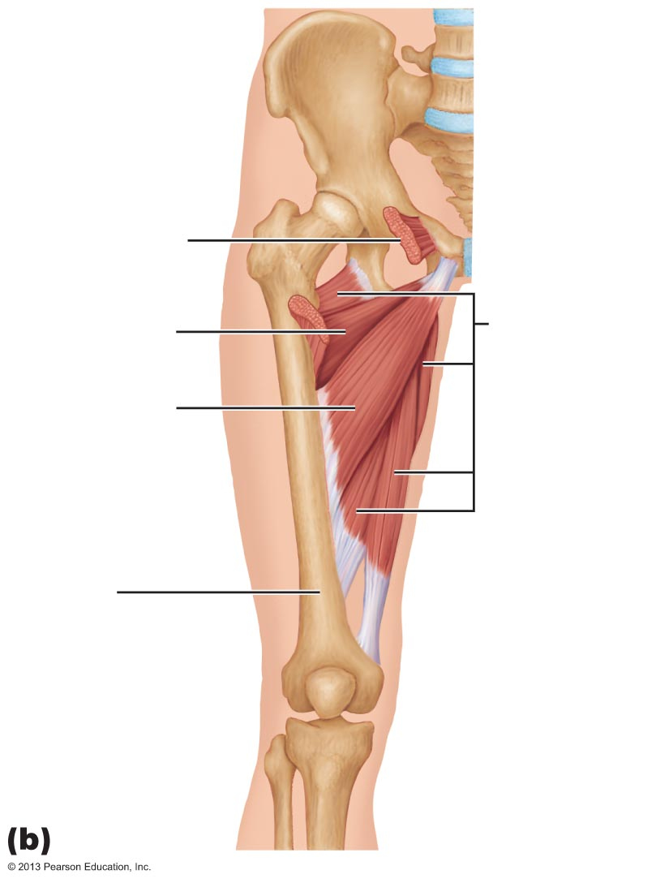 | ______________________________________________  ______________________________________________  ______________________________________________  ______________________________________________  ______________________________________________  ______________________________________________  ______________________________________________  ______________________________________________  ______________________________________________  ______________________________________________  ______________________________________________  ______________________________________________

3. List as many poses as you can that stretch the external rotators. Examine the external rotator group in the following image. Practice sukhasana before a pose that stretches the external rotator group and after. What do notice about the anterior tilt of the pelvis? Would the flexibility of the external rotator group affect forward bending poses? Explain.
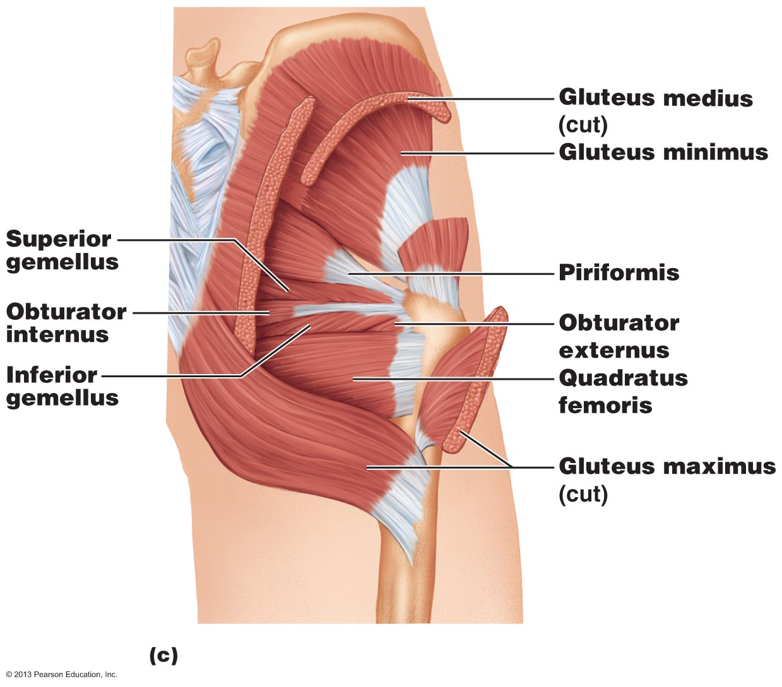 | _______________________________________  _______________________________________  _______________________________________  _______________________________________  _______________________________________  _______________________________________  _______________________________________  _______________________________________  ________________________________________

________________________________________________________________________________________________________________________________________________________________________________________________________________________________________________________________________________________________________________________________________________________________________________________________________________________________________________________________________________________________________________________________________________________________________________________________________________________________________________________________________________________________________________________________________________________

Recommended Reading:
- KM pgs. 79-95
- Learning external rotators and adductor muscles!!

