Terminology, Movements and Bones
      - In Utkatasana (chair pose) what movement occurs at the hip joint?
      - In Prasarita Padottanasana (standing straddle forward bend) describe how the hip joint has moved using movement terminology.

      - In Virabhadrasa II, describe all the movements that have occurred at the hip joint.

      - In Virabhadrasa I, describe the movement occurring at the shoulder joint.

      - Label the bones in the following graphic.

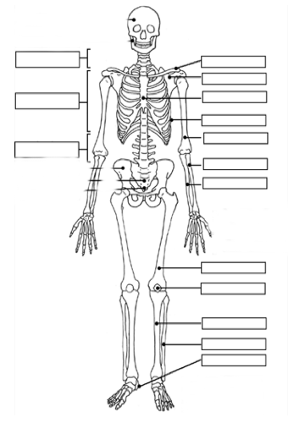

Need to Knows!
- Directional Terminology
  - Anterior : Posterior
  - Medial : Lateral
  - Deep : Superficial
- Movement Terminology
  - Flexion : Extension
  - Adduction : Abduction
  - Medial rotation : Lateral rotation
- Basic bone names

Associated Reading
1. Anatomy Terminology and skeleton anatomy:
a. Yoga manual: pgs 294-295, 64-65
b. Key Muscles: pgs 8-9, 13

Bonus Question: Name the special movements of the scapula and forearm.

